**Information System**

**Pharmaceutical company**

**Presented by:**

**Eng : Dalia Mostafa Alsadiq**

**Eng: Hesham Qutb**

**Eng: Hadeer Abdel Nasser**

**-Project Description:**

-The pharmaceutical industry discovers, develops, produces, and markets drugs or pharmaceutical drugs for use as medications to be administered (or self-administered) to patients, with the aim to cure them, vaccinate them, or alleviate the symptoms.[1][2] Pharmaceutical companies may deal in generic or brand medications and medical devices. They are subject to a variety of laws and regulations that govern the patenting, testing, safety, efficacy and marketing of drugs.

- We have a pharmaceutical company, and this company contains some entity such as doctors, drug, employee, hospital, manager, medical representative, patients and pharmacy, and every entity of countries has its own attributes such as the pin code, name, age, number, id, ssn, fax, age, address as shown in the screenshots and the main project

**ERD**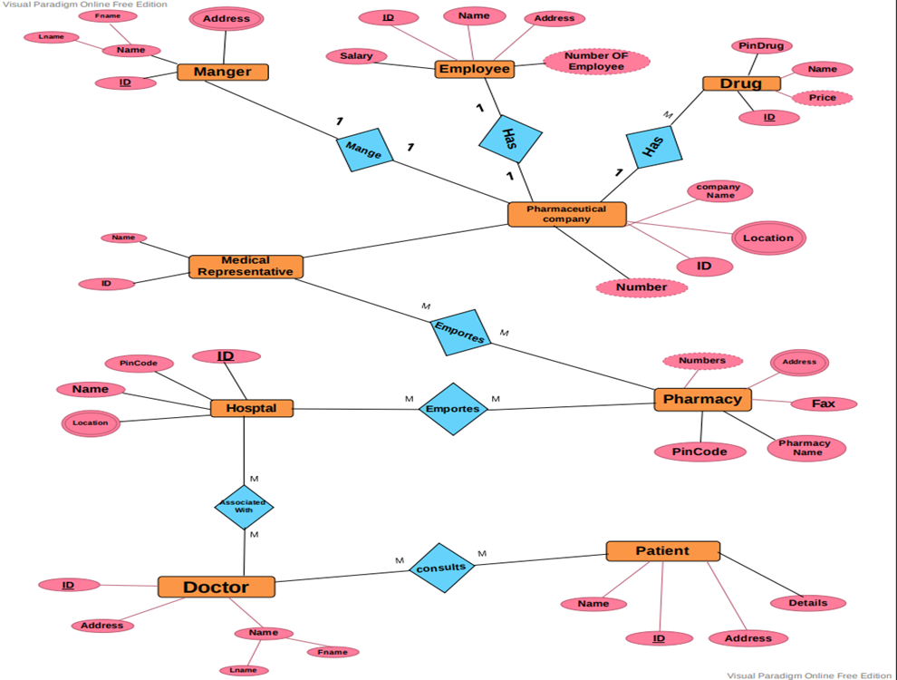

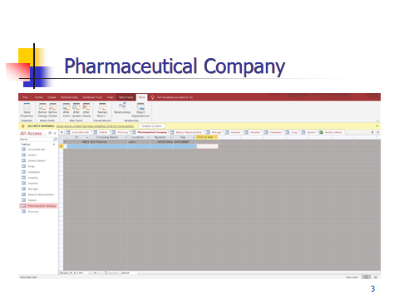

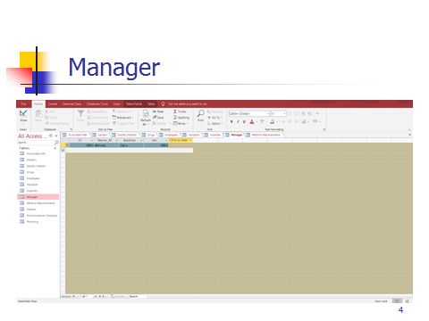

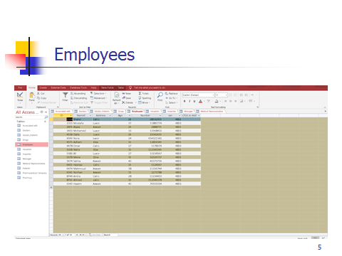

schema

